

Project Interim Report

On

AI CAREER AND GUIDANCE

(Using Python , scikit-learn , flask & MySQL Concepts)

RU-500-02-00002
Foundations of Machine Learning

SESSION: 2025-26

Submitted By Student name Riya Sahu
RU-25-11192

Master of Computer Applications with AI and ML in association with Google

Under the Guidance of Mr. Zamin Hamid

SCHOOL OF INFORMATION TECHNOLOGY
RUNGTA INTERNATIONAL SKILLS UNIVERSITY
BHILAI, CG

Abstract

The AI Career Guidance System is an intelligent and user-friendly application developed to assist students and job seekers in selecting suitable career paths based on their skills, interests, aptitude, and academic performance. Choosing the right career is one of the most important decisions in a person’s life, and many individuals face confusion due to a lack of proper guidance and awareness. This project aims to solve this problem by using Artificial Intelligence and Machine Learning techniques to provide accurate and personalized career recommendations.

The system collects user information such as educational qualification, technical skills, interests, industry preference, aptitude test scores, and strengths. Based on this input, the machine learning model analyzes patterns in the dataset and predicts the most appropriate career options for the user. The application provides smart recommendations that help users understand which field matches their capabilities and future goals.

The project is designed with an attractive and interactive web interface that allows users to easily select multiple skills and industries using dropdown menus and form-based inputs. The backend of the system is developed using Python and Flask, while the frontend uses HTML, CSS, and JavaScript for creating a responsive and professional user experience. Machine Learning libraries such as Scikit-learn, Pandas, and NumPy are used for data preprocessing, model training, and prediction.

The system improves career decision-making by reducing manual counseling efforts and providing instant guidance. It also helps educational institutions and career counselors in understanding student abilities more effectively. The project demonstrates the practical implementation of AI in the field of education and career development.

The main objective of this project is to create a reliable, efficient, and intelligent career recommendation platform that helps users make informed career choices, improve their confidence, and achieve better professional growth in the future.

Introduction

In today’s competitive and rapidly changing world, choosing the right career has become a difficult task for students and job seekers. Many individuals face confusion while selecting a career path because they are unaware of their strengths, skills, interests, and future opportunities available in different industries. Traditional career counseling methods are often time-consuming, expensive, and not easily accessible to everyone. Therefore, there is a growing need for an intelligent system that can provide accurate and personalized career guidance.
The AI Career Guidance System is developed to solve this problem by using Artificial Intelligence (AI) and Machine Learning (ML) technologies. The system analyzes user information such as skills, interests, aptitude test scores, educational background, and preferred industries to recommend suitable career options. By applying machine learning algorithms on career-related datasets, the system predicts career paths that best match the user’s profile.
The main purpose of this project is to help users make better career decisions with the support of technology and data analysis. The application provides instant recommendations and reduces dependency on manual counseling. It also improves the efficiency of career planning by offering personalized suggestions according to individual abilities and preferences.
The project is implemented using Python, Flask, HTML, CSS, JavaScript, and Machine Learning libraries such as Scikit-learn, Pandas, and NumPy. The frontend of the application is designed to be interactive and user-friendly, allowing users to easily enter their information through forms and dropdown menus. The backend processes the input data and generates career recommendations using trained machine learning models.
This system can be useful for students, fresh graduates, educational institutions, and career counselors. It demonstrates the practical application of Artificial Intelligence in the education and career development sector. The project not only enhances career awareness among users but also encourages the use of smart technologies for solving real-world problems.
The AI Career Guidance System aims to provide a reliable, efficient, and intelligent platform that assists users in identifying the most suitable career opportunities, thereby helping them build a successful and satisfying professional future.

Scope

The scope of the AI Career Guidance System is to provide an intelligent platform that helps students and job seekers identify suitable career paths based on their skills, interests, aptitude, and educational background. The system aims to simplify the career selection process by using Artificial Intelligence and Machine Learning techniques to generate personalized career recommendations.

This project can be widely used in schools, colleges, universities, training institutes, and career counseling centers to guide students in making better career decisions. It can also help fresh graduates and job seekers explore career opportunities that match their abilities and preferences. The system reduces confusion and provides quick guidance without requiring extensive manual counseling.

The project has the capability to:

Analyze user skills, interests, and aptitude data.

Recommend suitable career domains and job roles.

Provide personalized suggestions using Machine Learning algorithms.

Improve decision-making in career planning.

Offer a user-friendly web interface for easy interaction.

Store and manage user data efficiently.

Help educational institutions understand student strengths and career interests.

The future scope of the project can include:

Integration of real-time job market analysis and trending career opportunities.

Addition of online aptitude tests and personality assessment modules.

Use of Deep Learning and advanced AI models for more accurate predictions.

Integration with job portals and online learning platforms.

Multi-language support for wider accessibility.

Mobile application development for easy access on smartphones.

System Requirements
1. Hardware Requirements:
- Processor: Intel i3 or higher
- RAM: 4 GB minimum (8 GB recommended)
- Hard Disk: 20 GB free space or more
- Input Devices: Keyboard, Mouse
- Output Devices: Monitor/Display
2. Software Requirements:
- Operating System: Windows / Linux / macOS
- Programming Language: Python
- Frontend: HTML, CSS, JavaScript (or React.js)
- Backend: Flask / Django / FastAPI
- Database: MySQL / PostgreSQL / MongoDB
- IDE: VS Code / PyCharm
- Libraries: scikit-learn, pandas, NumPy, TensorFlow (optional)
3. Tools & Frameworks:
- Jupyter Notebook (for model training)
- Git/GitHub (version control)
- Postman (API testing)

Methodology

The methodology of the AI Career Guidance System explains the step-by-step process used to develop and implement the project. The system uses Machine Learning techniques to analyze user information and provide suitable career recommendations.
1. Requirement Analysis
In the first phase, the requirements of the system are identified. The project focuses on understanding the problems faced by students and job seekers while selecting a career path. Necessary features such as skill analysis, career prediction, and user interaction are planned during this stage.
2. Data Collection
A career-related dataset is collected from reliable sources such as Kaggle. The dataset contains information about skills, interests, educational qualifications, aptitude scores, industries, and career domains. This data is used to train the machine learning model.
3. Data Preprocessing
The collected data is cleaned and prepared before training the model. This process includes:
- Removing missing or duplicate values
- Converting categorical data into numerical form
- Data normalization and formatting
- Feature selection for better accuracy
Libraries such as Pandas and NumPy are used for preprocessing the dataset.
4. Model Training
Machine Learning algorithms are applied to train the system using the processed dataset. Algorithms such as:
- Logistic Regression
can be used for prediction and classification. The model learns patterns from the dataset and predicts suitable career options based on user input.
5. System Development
The web application is developed using:
- Python for backend programming
- Flask framework for connecting frontend and backend
- HTML, CSS, and JavaScript for designing the user interface
Interactive forms, dropdown menus, and multiple skill selection options are added to improve user experience.
6. User Input and Prediction
Users enter their details such as skills, interests, educational background, and preferred industry through the web interface. The trained model processes the input and generates personalized career recommendations.
7. Testing and Evaluation
The system is tested to check prediction accuracy, functionality, and user interface performance. Different test cases are used to ensure that the system provides correct and efficient career suggestions.
8. Result Generation
After successful prediction, the system displays the recommended career paths to the user. The output helps users understand which careers are most suitable according to their abilities and interests.
9. Future Enhancement
The methodology also supports future improvements such as:
- Real-time job recommendations
- AI chatbot integration
- Online aptitude tests
- Mobile application support
- Advanced Deep Learning models for better prediction accuracy
Thus, the methodology provides a systematic approach for developing an intelligent and efficient AI-based career guidance system.

Flowchart

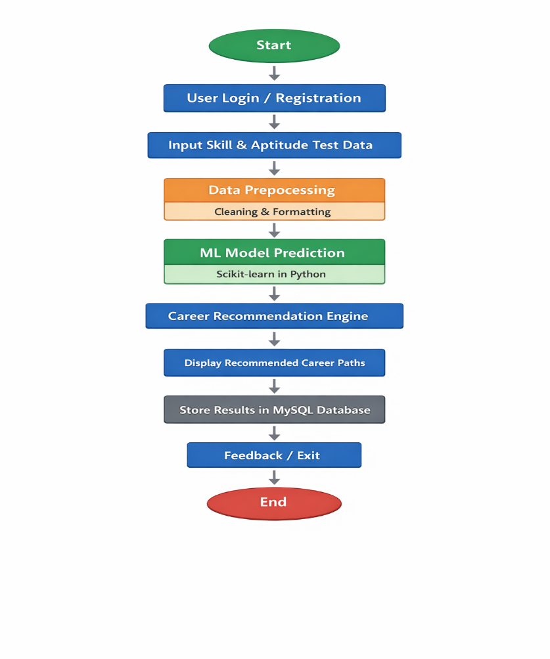

• The process starts when the user opens the system (Start).
• The user performs Login or Registration to access the application.
• The system collects skill and aptitude test data from the user.
• The collected data is cleaned and processed in the Data Preprocessing stage.
• The processed data is passed to the Machine Learning model built using Scikit-learn in Python for prediction.
• The model analyzes the input and generates career recommendations.
• The system displays the recommended career paths to the user.
• All results are stored in the database using MySQL for future use.
• The user can provide feedback or exit the system.

• Finally, the process ends (End).

Templates

Index.html

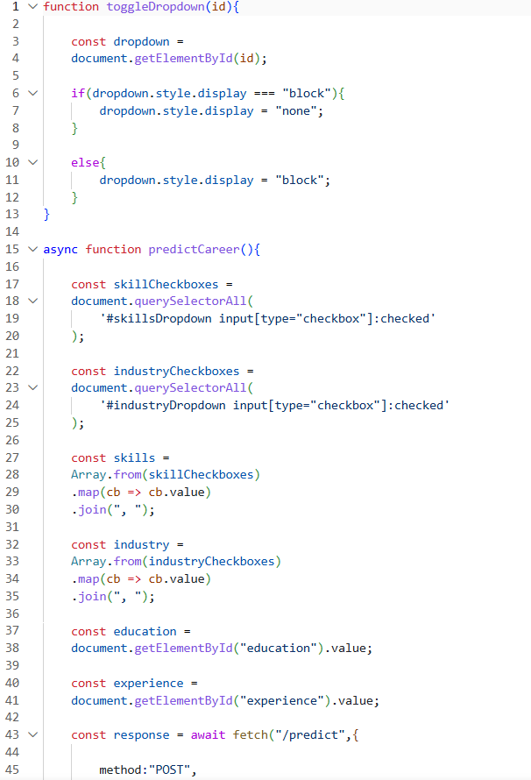

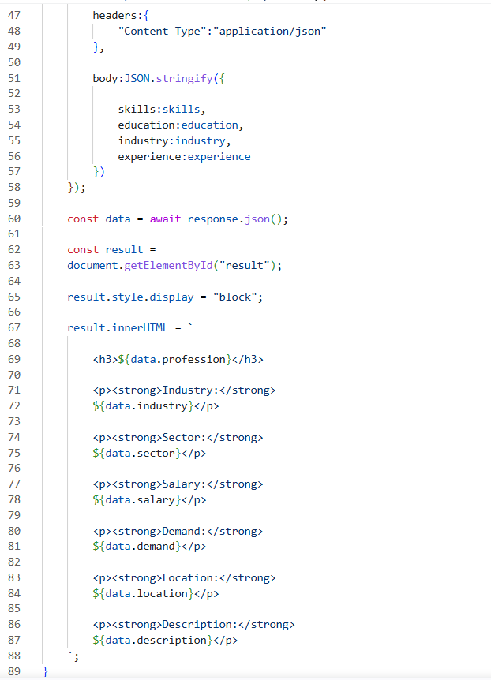

App.py

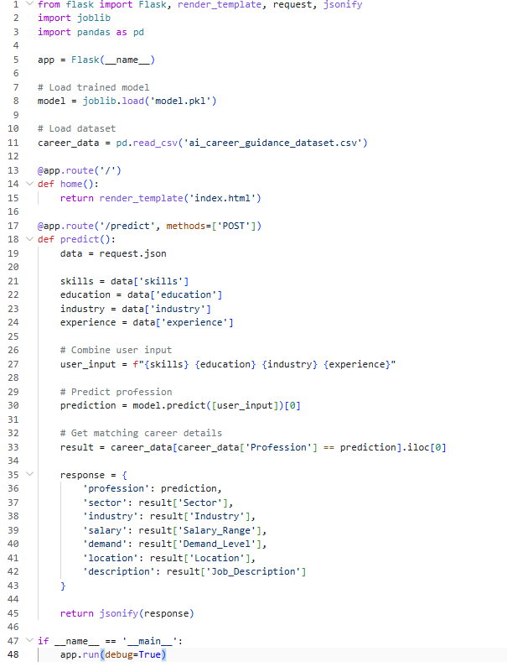

Train_model.py

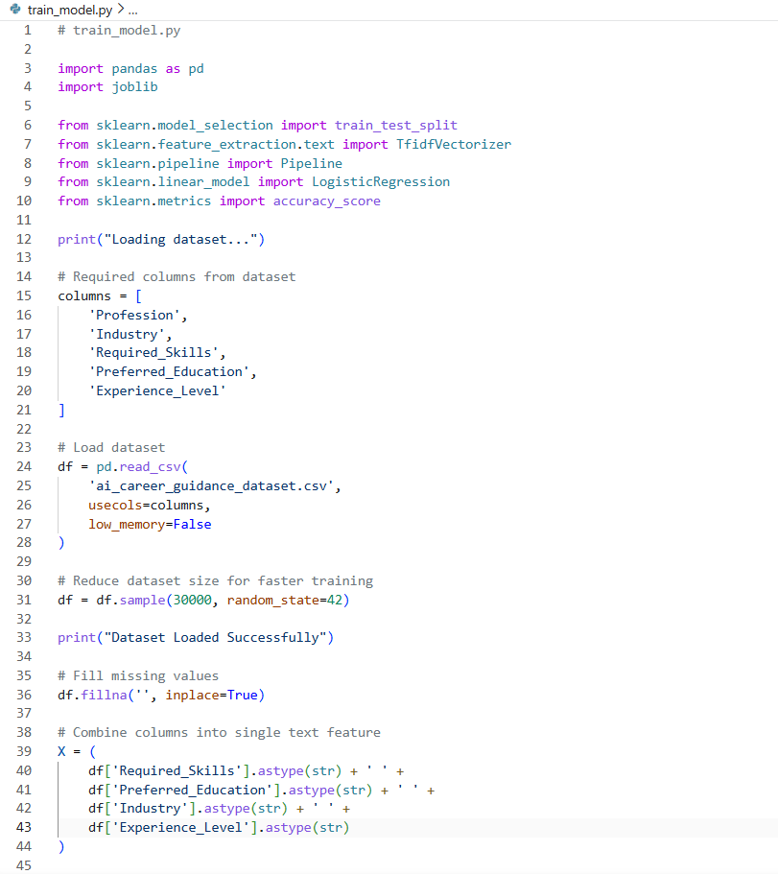

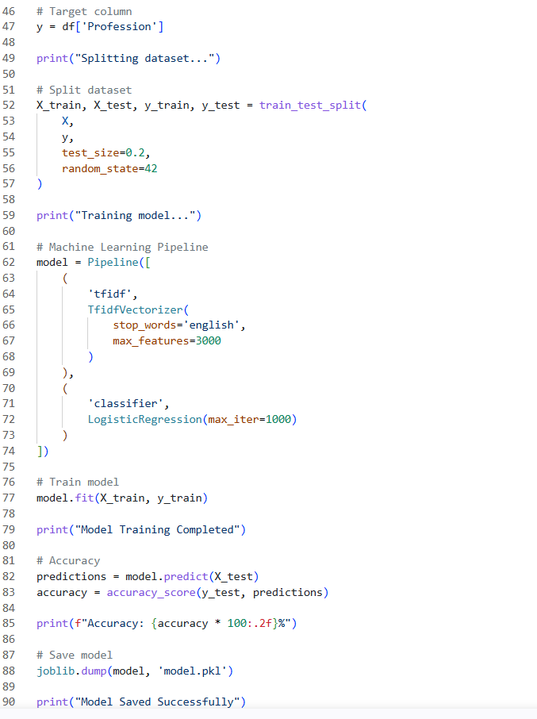

Implementation

1. Implementation Overview
The AI Career Guidance System is implemented using Python-based machine learning techniques. It collects user input, processes data, applies ML algorithms, and generates personalized career recommendations.

2. System Flow Diagram
+-------------------+
| User Input |
| (Skills, Aptitude,|
| Interests) |
+---------+---------+
|
v
+-------------------+
| Data Collection |
+---------+---------+
|
v
+-------------------+
| Data Preprocessing|
| (Cleaning, |
| Normalization) |
+---------+---------+
|
v
+-------------------+
| ML Model |
| (Classification / |
| Recommendation) |
+---------+---------+
|
v
+-------------------+
| Career Matching |
| Engine |
+---------+---------+
|
v
+-------------------+
| Result Generation |
| (Career Options, |
| Skills, Scope) |
+---------+---------+
|
v
+-------------------+
| User Output |
+-------------------+

3. Implementation Steps
- Collect user data through a web form or questionnaire.
- Store data in a database (MySQL/MongoDB).
- Preprocess data using Python (pandas, NumPy).
- Train ML model using scikit-learn.
- Predict suitable career paths.
- Display results using frontend (HTML/CSS/React).

4. Outcome
The system provides personalized and data-driven career recommendations based on user inputs and AI analysis.

5. System Workflow
The workflow of the AI Career Guidance System describes how the system operates from user interaction to final output generation. First, the user accesses the system and enters required details such as skills, aptitude test scores, interests, and personal preferences through a web interface or form.
Next, the system collects and stores this input data in a database for processing. The data is then passed to the preprocessing stage, where it is cleaned, normalized, and converted into a structured format suitable for analysis.
After preprocessing, the machine learning model analyzes the data and identifies patterns by comparing the user profile with trained career datasets. Based on this analysis, the system predicts the most suitable career options using classification or recommendation techniques.
The predicted results are then sent to the output module, where personalized career suggestions are generated. These suggestions may include recommended career paths, required skills, job roles, and future scope.
Finally, the results are displayed to the user through the interface. The system may also collect user feedback to improve future recommendations and enhance model accuracy.

Gantt Chart

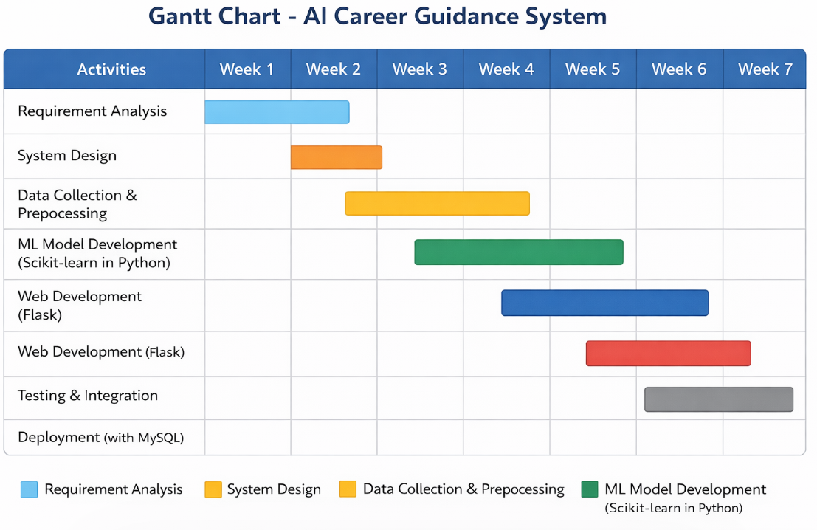
.
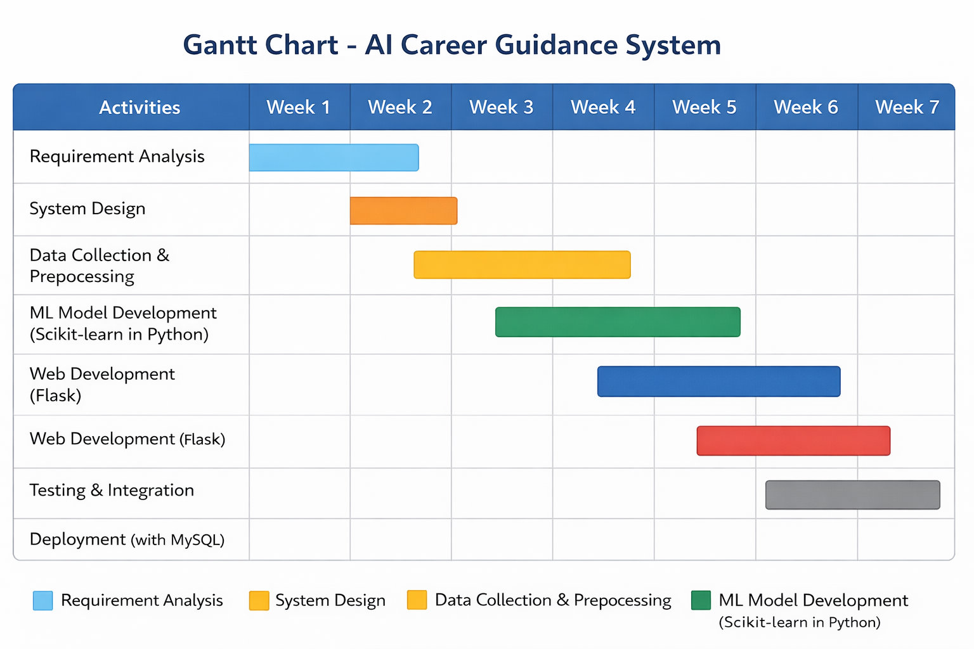

Conclusion

The AI Career Guidance System is an intelligent and effective solution developed to help students and job seekers choose suitable career paths based on their skills, interests, aptitude, and educational background. The project successfully demonstrates the use of Artificial Intelligence and Machine Learning in the field of education and career counseling.

The system analyzes user data and provides personalized career recommendations, making the career selection process easier, faster, and more accurate. It reduces the dependency on traditional counseling methods and helps users make informed decisions about their future. The user-friendly interface and automated prediction process improve accessibility and efficiency for individuals seeking career guidance.

Through this project, various technologies such as Python, Flask, HTML, CSS, JavaScript, Pandas, NumPy, and Scikit-learn were implemented to build a complete working model. Machine Learning algorithms were used to train the system and improve prediction accuracy based on user inputs and datasets.

The project also highlights the importance of data-driven decision-making in modern career planning. It can be highly beneficial for schools, colleges, career counselors, and training institutions in understanding student capabilities and guiding them effectively.

In the future, the system can be enhanced by integrating real-time job market analysis, online aptitude tests, chatbot support, mobile applications, and advanced AI models for more accurate recommendations. Overall, the AI Career Guidance System provides a smart, reliable, and innovative platform that helps users identify suitable career opportunities and supports them in building a successful professional future.

References

[1] Python Software Foundation, “Python Documentation,” Accessed: May 21, 2026.
[2] Flask Documentation, “Flask Web Framework Documentation,” Accessed: May 21, 2026.
[3] Scikit-learn Documentation, “Scikit-learn: Machine Learning in Python,” Accessed: May 21, 2026.
[4] Pandas Documentation, “Pandas User Guide,” Accessed: May 21, 2026.
[5] NumPy Documentation, “NumPy Reference Guide,” Accessed: May 21, 2026.
[6] Kaggle, “Career Guidance and Skill Datasets,” Accessed: May 21, 2026.
[7] W3Schools, “Web Development Tutorials,” Accessed: May 21, 2026.
[8] MDN Web Docs, “HTML, CSS, and JavaScript Documentation,” Accessed: May 21, 2026.
[9] GeeksforGeeks, “Python and Machine Learning Tutorials,” Accessed: May 21, 2026.
[10] GitHub, “Open Source Project Repository,” Accessed: May 21, 2026.
[11] Stack Overflow, “Programming Discussion and Debugging Platform,” Accessed: May 21, 2026.

